WELCOME TO CALVARY BAPTIST Sept.15, 2019

THIS MORNING

**WELCOME**

**PRAYER**

**OPENING WORSHIP**

**SCRIPTURE READING Acts 11:1-18 (pp. 919-920)**

*Jeff Harris*

**TITHES & OFFERINGS**

**MESSAGE** *Josh Bonner*

*"The Vanity of Privilege"*

*Ecclesiastes 4:1-16*

**CLOSING WORSHIP**

**BENEDICTION**

WEEKLY ACTIVITIES

**SUNDAY MORNINGS**

**Coffee & Donuts @ 8:30 AM // Sunday School @ 9 AM // Morning Worship @ 10:15 AM**

**WEDNESDAY EVENINGS**

**Weekly dinners at 5:30. AWANA, Youth group and Adult Bible Study at 6:30 p.m.**

**TRAIL LIF**

**TRAIL LIFE TROOP SD-2018--Boys in Kindergarten-8th grade are invited to join Trail Life. For details & activities schedule contact Lester DeLashmutt. Facebook: @troopsd2018.**

**AMERICAN HERITAGE GIRLS--TROOP SD-3125--Girls in Kindergarten-5th grade are invited to join AHG this Fall. Activities will focus on FAITH // SERVICE //FUN. See Jennifer Bonner for more details.**

NEWS AND EVENTS

**CHILDREN'S CHURCH** // We now have Children's Church every 3rd & 4th Sundays. // Please see Jeff Baum if you'd like to volunteer in this ministry.

**SMALL GROUPS BEGIN TONIGHT!** // We have some great studies lined up for the Fall! // Check out the front table for details, and to sign up!

**MENS BREAKFAST** // Sat., Sept. 21, 7:30 AM. // We will be meeting for breakfast then heading to Carol Hendrickson's ranch to do some manual labor and clean up. // We will also be doing some apple picking if families want to join!

**YOUTH MISSION PROJECT & BONFIRE //** We will be going to Carol Hendrickson's ranch on Saturday, Sept. 21, from 5-8 p.m. to help pick apples, and enjoy hotdogs and s'mores around a bonfire. // Bring a friend!

**WOMEN'S POTLUCK** // Sept. 23, 6 p.m., at the church. Kaye Carson will be joining us to teach us the process of planning and leading a devotion. Bring a friend!

**SAW YOU AT THE POLE EVENT //** Youth! Join us for a community-wide youth event, Sept. 25, 6-8 p.m., at Bethel Assembly of God Church. // There will be games, pizza and an Air Pod giveaway. // Tru-Serva will be in concert--a rapper from St. Paul, Minnesota. (He has been at Hills alive). // Let Chris or Pam know if you need a ride.

**ORDINATION** // Sept. 29, Tom Scott.

FOR OUR CHURCH CALENDAR, VISIT CALVARYBAPTISTRC.COM/

MONTHLY-CALENDAR

**COMING UP**

Sept. 15 Children's Church

Sept. 15 Small Groups Begin

Sept. 17 Trail Life Troop/AHG

Sept. 19 Love Inc. Meal

Sept. 21 Men's Breakfast/Work Day

Sept. 21 Youth Mission Day/Bonfire

Sept. 22 Ordination Council

Sept. 22 Children's Church

Sept. 23 Ladies' Potluck

Sept. 25 See You At The Pole

Sept. 25 Saw You at the Pole Event

Sept. 29 Ordination

Oct. 6 Cornerstone Meal

WELCOME

FREE GIFT FOR YOU!

Access over 20,000 Bible study videos, biblically based kids videos and much more for FREE. There's something for everyone and you can watch anytime, anywhere. Be sure to create your RightNow Media account at rightnowmedia.org/account/invite/cbcrc for free access.

We're so happy you joined us today!

**NEW HERE?**

Thank you for visiting today. We hope you will find Calvary to be a place that seeks to glorify God, preach the gospel and show God's love to others.

We invite you to fill out the CONNECTION CARD below and drop it in the offering plate or give it to one of our pastors.

**WHERE DO MY KIDS GO?**

**NURSERY CARE** is for infants to 4 years old. Check your kids into one of the rooms in the foyer, then join the service.

**CHILDREN'S BULLETINS** are also available in the foyer for kids 5 and up.

**HAVE A PRAYER REQUEST, NEEDS?**

Contact the Deacon of the Month

**Jeff Harris**

**(605) 645-0568**

**CHURCH LEADERSHIP**

**PASTORS**

**Dr. Josh Bonner** *Senior Pastor for Preaching & Vision*

**Chris Causey** *Associate Pastor for Education & Administration*

**DEACONS**

Dr. Dave White (Chair) Jeff Harris

Jim Dotson Todd Warren

**Connection Card**

**NAME ___________________________________**

Single Married **___________________**

**ADDRESS _______________________________**

**CITY ____________ STATE ___ ZIP __________**

**EMAIL ___________________________________**

**PHONE __________________________________**

**CHILDREN AT HOME** **________________________**

**_____________________________________________**

I am: New to the Community Living in the Area

Looking for a church home Visiting the Black Hills

I found out about Calvary Baptist through:

Driving by Facebook Website Phonebook

Family/Friend Other ______________________

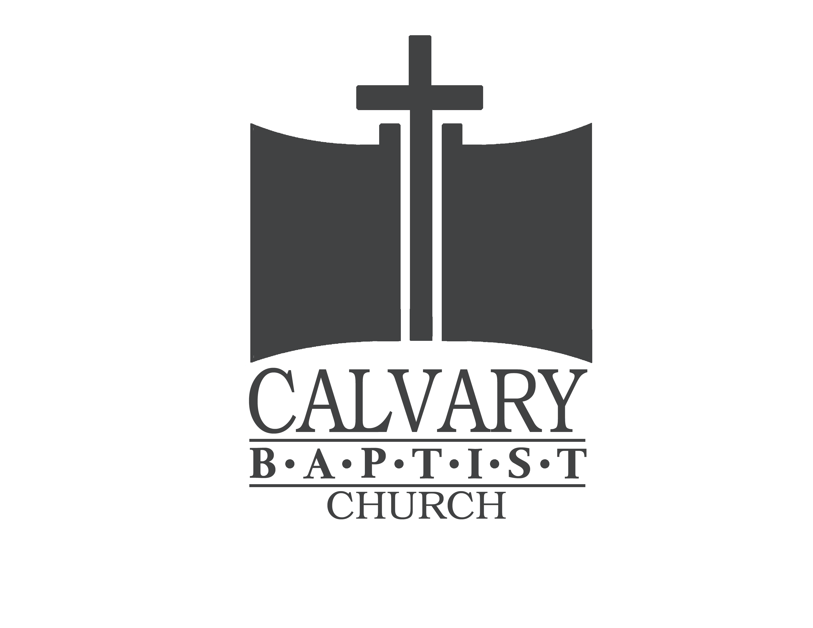

**CALVARY BAPTIST CHURCH**

*Home of Calvary Christian School*

4601 Mt Rushmore Rd (57701) - PO Box 2434 (57709)

Rapid City, South Dakota

Church 605-342-3384 School 605-348-5175

Church Email: calvary@rapidnet.com

www.calvarybaptistrc.com

Facebook: *Calvary Baptist Church - Rapid City*